INFRASTRUCTURE FUNDING STATEMENT

Annual statement for Canterbury City Council for financial year 2020/2021

December 2021
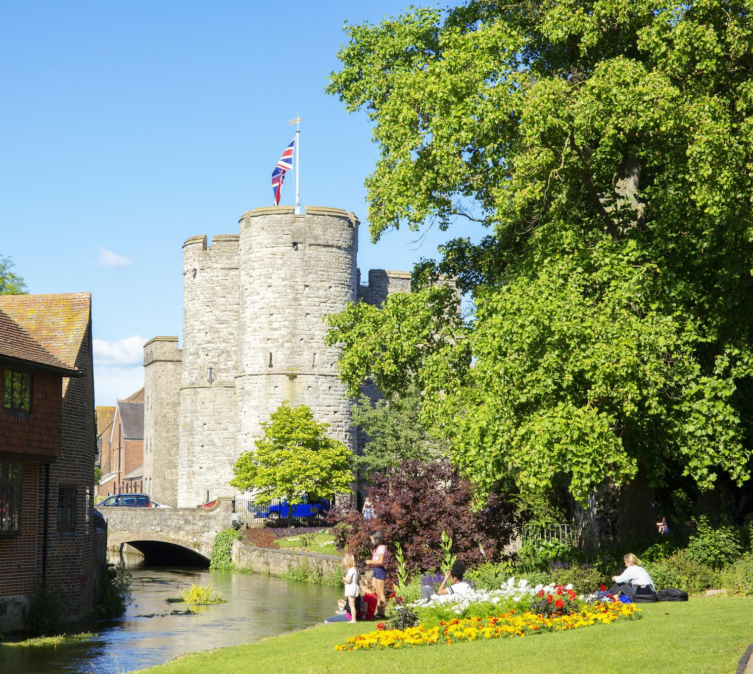

Visit Canterbury (c) Alex Hare

Table of Contents

Table of Contents 2
Introduction 4
What are developer contributions? 4
Definitions 5
Status of contributions 5
Infrastructure types 5
Headlines 7
Key total figures for developer contributions in financial year 2020/2021 7
CIL Report 8
What is the Community Infrastructure Levy (CIL)? 8
Total CIL secured and received in 2020/2021 8
Administrative expenses 9
‘Neighbourhood portion’ 9
Strategic infrastructure projects 10
Allocated CIL receipts for financial year 2020/2021 10
Further information required in the CIL report for the reported year 2020/2021 11
Allocated receipts 11
CIL expenditure 11
CIL and the Neighbourhood Portion 12
Retained CIL receipts at the end of the reported year 12
Section 106 Report 13
What are Section 106 agreements or planning obligations? 13
Total S106 agreements for financial contributions secured for the reported year 14
Obligations secured per purpose 14
Non-monetary contributions entered into during the reported year 16
Total S106 agreements for financial contributions received for the reported year 18
Obligations received per purpose 18
Total S106 agreements for financial contributions allocated but not spent in the reported year 20
Allocated obligations per purpose 20
Developer contributions held at the end of financial year 2019/20 22
Developer contributions spent in financial year 2019/2020 22
Total contributions spent, per purpose 22
Examples of recent s106 developer contribution spend 25
Repaving scheme in lower St Margaret's Street 25
Crab and Winkle Cycle Route Extension 26
Amount of money spent in respect of monitoring s106 contributions 28
Future spending priorities 29
Appendices 30
CIL Report from Hoath Parish Council 30
Total S106 Developer Contributions Allocated 30

Introduction

  - Welcome to our second annual Infrastructure Funding Statement (IFS).
  - The IFS has been produced in accordance with the Community Infrastructure Levy Regulations 2010 (as amended).
  - The purpose of the statement is to illustrate the income and expenditure relating to developer contributions for the financial year 2020/2021 (1st April 2020 to 31st March 2021).
  - Along with summary information, the IFS also contains examples of infrastructure projects funded by developer contributions which have been delivered by Canterbury City Council in the financial year 2020/2021.

What are developer contributions?
  - The purpose of developer contributions is to ensure that developers address or mitigate the impacts of their development on infrastructure. Types of infrastructure include open space such as play areas and parks, schools, transport and community facilities.
  - Mitigation can be made as financial contributions by way of the Community Infrastructure Levy (CIL) or Section 106 (s106) agreements (also known as planning obligations). Alternatively, planning permissions may require that developers provide infrastructure directly.
  - Canterbury City Council began charging CIL from 1 April 2020. This year’s statement will therefore feature information on developer contributions collected via CIL as well as through s106 agreements.
  - Canterbury City Council anticipates that s106 agreements will decrease over time and that CIL will become the primary method for collecting developer contributions from small and medium sized sites.

Definitions

Status of contributions
  - Secured - in CIL, this means that the demand notice has been issued and the developer is now required to pay all or part of their CIL liability. In terms of s106 agreements, a contribution is secured when it is included within a signed legal document attached to a planning permission. For both CIL and s106, these contributions have not been collected/delivered and if the planning permission is not implemented, they will never be received.
  - Received - contributions received, either monetary or non-monetary (in kind) to Canterbury City Council.
  - Allocated - contributions that have been received and allocated to specific projects. It also includes sums which will be knowingly passed to an external organisation but which are yet to be transferred.
  - Spent/delivered - Monetary or non-monetary contributions that have been spent or delivered. In the case of s106 contributions collected for external organisations such as Kent County Council or NHS, the contribution is deemed as spent once it has been transferred to the receiving body.

Infrastructure types
  - Affordable housing - commuted sums/a financial contribution which is allocated by Canterbury City Council's Property and Regeneration team, to be used for the purpose of enabling affordable housing in the district, either by the council or by a Registered Provider.
  - Business support - 'one to one' or group support to help local businesses with issues (eg social media, website, and property issues etc).
  - East Kent SAMMS - contributions made to Bird Wise East Kent, a partnership of local authorities and conservation organisations, who mitigate the potential recreational disturbance to bird populations on the Special Protection Area of the Thanet Coast and Sandwich Bay.
  - Health - contributions that are secured and received for and spent and allocated by NHS Kent and Medway Clinical Commissioning Group (CCG).
  - KCC - contributions secured, received and transferred to Kent County Council (KCC).
  - North Kent SAMMS - contributions made to Bird Wise North Kent, otherwise known as the North Kent Strategic Access Management and Monitoring Scheme (SAMMS) board. It is a partnership of local authorities, developers and environmental organisations, who mitigate the potential recreational disturbance from development on bird populations on the Thames, Medway and Swale estuaries, which are designated Special Protection Areas and Ramsar sites.
  - Open space - contributions that are secured and received for and spent and allocated by Canterbury City Council's Environment team, to be used for the purpose of open spaces, gardens and parks in the district.
  - Sustainable transport - contributions that are secured and received for and spent and allocated by Canterbury City Council's Transportation team on sustainable transport initiatives. Other transportation schemes are funded by KCC Highways.

Headlines

Key total figures for developer contributions in financial year 2020/2021

  - CIL

- CIL invoiced (set out in Demand Notices): £229,000.
- Total CIL received: £97,000.
- Allocation and spend of CIL funds to follow in later financial years.

  - s106

- Total secured or pledged, to be collected by Canterbury: £3m
- Total affordable housing units secured: 258 units
- Total received (secured in any financial year): £2.1m
- Total allocated to infrastructure provision/improvement (secured in any financial year): £5.3m
- Total spent/transferred to external bodies to spend: £350,000

Please note that the figures are rounded up to the nearest thousand.
There is more information on each headline figure within the statement.

CIL Report

What is the Community Infrastructure Levy (CIL)?
  - CIL was introduced nationally in 2010 and has been charged in Canterbury City Council since 1 April 2020.
  - CIL is a set charge on most new development, based on the gross internal area floorspace of buildings, to help to fund the provision and improvement of infrastructure needed to address the cumulative impact of development across the district.
  - Canterbury Council’s CIL Charging Schedule, which sets out the CIL charging rates, is available on the CIL and Planning Obligations pages on our website.
  - A CIL charge is payable either within 60 days of commencement of a development or within the terms of an instalment policy set by the CIL charging authority. Canterbury Council allows CIL to be paid in instalments where the chargeable amount is equal to or greater than £50,000. More information can be found in our Instalments and Payment in Kind Policy.
  - The whole sum payable and the instalments required is set out within the CIL Demand Notice for each CIL chargeable development. Due to instalments, CIL Demand Notices issued during a particular year do not necessarily equate to CIL sums likely to be received during that year.
  - In addition, developments can be altered through further planning permissions over time, often resulting in revised Demand Notices needing to be issued. Any such reissued Notices are not double-counted in this report; if a Demand Notice is issued and then reissued in the same reporting year, only the reissued Notice would be included within the figure for CIL invoiced during the year.
  - Further information on CIL can be found in the CIL guidance provided by the Department for Levelling Up, Housing and Communities.

Total CIL secured and received in 2020/2021
  - The total CIL which was invoiced (as set out in Demand Notices) in the reported year is £228,864.52.
  - The total CIL receipts received in the reported year is £96,844.04.
  - These figures include any late payment or other surcharges, and any late payment interest, included in Demand Notices.

Total CIL allocated and spent in 2020/2021
  - CIL collected will be used to provide infrastructure to support growth within the district. Of this:

Administrative expenses
  - 5% of total CIL receipts collected in the reported year was both allocated to and spent on administrative expenses associated with the levy such as the set up and software costs and ongoing monitoring/operation.

‘Neighbourhood portion’
  - The CIL Regulations stipulate that the CIL Charging Authority must pass 15% of local CIL receipts to the parish council for the area where a CIL liable development takes place, rising to 25% if the parish has a Neighbourhood Plan in place. This is sometimes known as the neighbourhood portion.
  - For receipts collected from a development in a parished area, the neighbourhood portion is automatically allocated to the respective parish. The neighbourhood portion is then transferred to parishes twice yearly, in October and in April, but a parish may request early release of funds to facilitate a project.
  - Parish councils may spend the neighbourhood portion on anything that is concerned with addressing the demands that development places on the parish’s area. Parish councils are encouraged to work closely with the community and with Canterbury City Council to identify spending priorities.
  - In the reported year, Canterbury City Council received a CIL neighbourhood portion for Hoath parish only. This amount was transferred to Hoath Parish Council in the same reported year.
  - Parishes which receive neighbourhood funds through the levy are obliged to report this information (see the appendix for the report from Hoath council).
  - In unparished areas (the city of Canterbury, and Herne Bay and Whitstable towns), the CIL Charging Authority can spend equivalent amounts in the locality, informed by engagement with local communities.
  - Canterbury City Council seeks to engage with communities in these urban areas to understand the spend priorities, for example, through gathering opinion in the Residents Survey in 2022.

Strategic infrastructure projects
  - The remaining receipts (80% of total receipts) must be spent on infrastructure needed to support the development of the area. It can be used to fund a wide range of infrastructure including schools, transport, open spaces and parks, GP surgeries and other health and social care facilities.
  - This pot of CIL receipts will be used to deliver important infrastructure projects which will not be funded by s106 agreements but which are needed to support the cumulative impacts of Local Plan growth. These projects are identified in Part Two of the council’s Infrastructure Delivery Plan.
  - The Infrastructure Delivery Plan will be updated alongside the new Local Plan to 2040.
  - Canterbury City Council is in the process of setting up governance arrangements for how this pot of CIL receipts is allocated and spent.

Allocated CIL receipts for financial year 2020/2021

  - The figures are split into the aforementioned headings for the financial year 2020/21 in the following table:
CIL ‘pot’ | Received | Allocated | Spent
Neighbourhood portion for parishes | £2,765.73 | £2,765.73 | £2,765.73
Neighbourhood portion for non-parished (urban) areas | £11,760.88 | £0.00 | £0.00
Strategic infrastructure | £77,475.23 | £0.00 | £0.00

  - In addition, the amount of CIL collected towards and spent on administration expenses is £4,842.20.

Further information required in the CIL report for the reported year 2020/2021

Allocated receipts

Information | Total
Total amount of CIL receipts which were collected before the reported year and which of these receipts are allocated or have not been allocated | £0.00
Total amount of CIL receipts, whenever collected, which were allocated but not spent during the reported year | £0.00
In relation to CIL receipts, whenever collected, which were allocated but not spent during the reported year, summary details of the items of infrastructure on which CIL has been allocated  and the amount of CIL allocated to each item | Not applicable

CIL expenditure

Information | Total
The total amount of CIL expenditure for the reported year | £7,607.93
Summary details of:
The items of infrastructure on which CIL (including land payments) has been spent, and the amount of CIL spent on each item | - £4,842.20 spent on administrative expenses  - £2,765.73 transferred to Hoath council
The amount of CIL spent on repaying money borrowed, including any interest | £0.00
The amount of CIL spent on administrative expenses and that amount expressed as a percentage of CIL collected in that year | £4842.20 (5% of total receipts)

CIL and the Neighbourhood Portion

- Information | Total
The amount of CIL passed to:
Any parish council under Regulation 54A or 59B (funds or land transferred to parish council) | £2,765.73
Any person under regulation 59(4) | £0.00
Summary details of the receipt and expenditure of CIL to which regulation 59E or 59F applied during the reported year including:
The total receipts that regulations 59E and 59F applied to | £11,760.88
The items of infrastructure to which the CIL receipts to which regulations 59E and 59F applied have been allocated or spent, and the amount of expenditure allocated or spent on each item | £0.00
Summary details of any notices served in accordance with regulation 59E, including:
The total value of CIL receipts requested from each parish council | £0.00
Any funds not yet recovered from each parish council at the end of the reported year | £0.00

Retained CIL receipts at the end of the reported year

- Information | Total
The total amount of:
CIL receipts for the reported year retained at the end of the reported year other than those to which regulation 59E or 59F applied | £77,811.83
CIL receipts from previous years retained at the end of the reported year | £0.00
CIL receipts for the reported year to which regulation 59E or 59F applied retained at the end of the reported year | £11,760.88
CIL receipts from previous years to which regulation 59E or 59F applied retained at the end of the reported year | £0.00

N.B. please see the CIL Regulations for further information.

Section 106 Report

What are Section 106 agreements or planning obligations?
  - Section 106 of the Town and Country Planning Act 1990 enables a Local Planning Authority to enter into a negotiated agreement – a planning obligation - to mitigate the impact of a specific development, to make it acceptable in planning terms.
  - The planning obligation might, for example, require the provision or contribution to a new or improved road, school, health facility or local green infrastructure. Local planning authorities can also seek planning obligations to secure a proportion of affordable housing from residential developments. In some instances, s106 planning obligations may require payments to be made to the county council or parish councils.
  - Canterbury City Council collects some contributions on behalf of Kent County Council, for example, for Education, Libraries and Adult Social Care. However, the majority of contributions for Kent County Council are secured and collected directly by the county council. More information can be found in Kent County Council’s annual Infrastructure Funding Statement.
  - Section 106 agreements or planning obligations are made between the council and developers. Although the agreements are signed by the developer, it's the land itself that becomes bound by a legal agreement and therefore viewable on the local land charge register
.
  - Commonly, agreements will include obligations for payment of money to the council as mitigation for impacts of a proposed development, such as providing for community infrastructure.
  - Canterbury City Council also requires planning obligations for developments affecting Special Protection Areas. These areas cover the Thames, Medway and Swale estuaries and marshes, and Thanet Coast and Sandwich Bay. Following a significant decline in important bird species in Kent, Canterbury City Council has worked with Natural England to create Strategic Access Management and Monitoring Strategies (SAMMS) for these protected sites. If a development is in the SAMMS area, the developer must contribute towards mitigation measures for these areas. The contribution is only paid for new dwellings,including holiday homes, and is paid on the basis of the number of bedrooms proposed in the development.
  - Read more about Planning Obligations on the council website.

Total s106 agreements for financial contributions secured for the reported year
  - The following table shows the total developer contributions secured through planning obligations in the reporting year. Although 'secured' through the legal agreement, these contributions only become payable when a 'trigger' for the obligation (as outlined in the agreement) is met.
  - Common triggers include: 'on commencement of a certain phase' or 'when development is occupied by a certain percentage'. If a development is not implemented or not completed, it may not meet the triggers and therefore the obligation is not collected.

Obligations secured per purpose

Purpose | Amount
Health | £1,221,480.00
East Kent SAMMS | £642,829.00
Open Space | £452,838.59
Sustainable Transport | £302,650.00
Affordable Housing | £207,000.00
North Kent SAMMS | £118,217.83
KCC | £24,089.60
Total | £2,969,105.18

  - The pie chart below depicts the data in table 5.10:

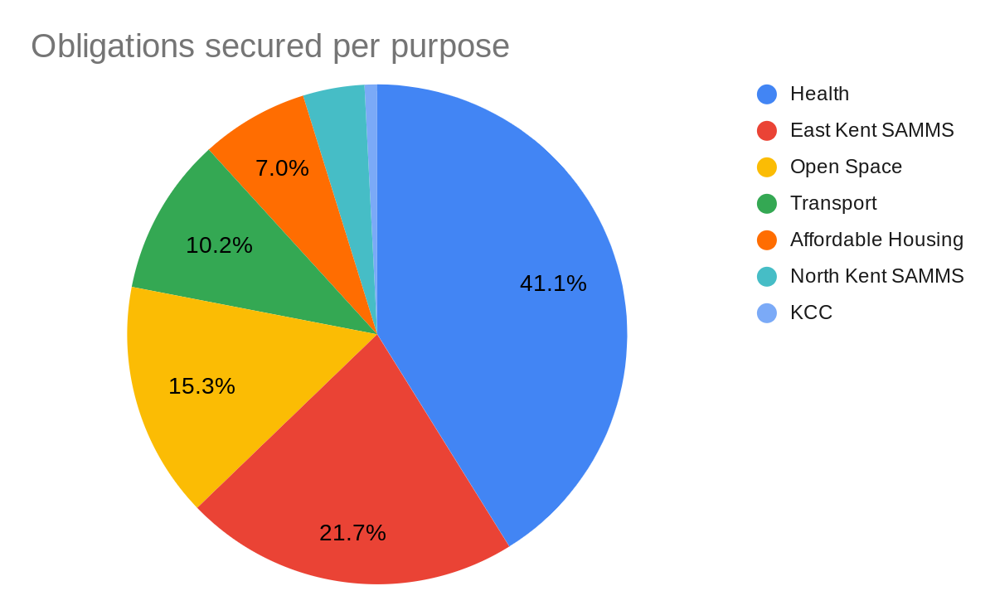

  - The figure for KCC in the data above includes all money secured for KCC which Canterbury City Council will collect on behalf of KCC and transfer to KCC once received and required.
  - The KCC figure in the data above does not include money secured for KCC which KCC will collect directly. This information can be found in Kent County Council’s Infrastructure Funding Statement.
  - The total for KCC in 5.9 and 5.10 consists of £23,609.60 secured for Primary Education and £480.16 secured for Libraries.
  - Examples of notable s106 agreements signed in financial year 2020/2021:

Application | Amount | Purpose
CA/20/02826 Sturry/Broad Oak & CA//18/00868 Broad Oak Farm | £842,400.00 | Refurbishment, reconfiguration and/or extension of Northgate Medical Practice, Canterbury.
CA//18/00868 Broad Oak Farm | £328,138.98 | Provision of recreational facilities and improvements at the Hersden Recreation Ground.
CA/20/00742 Former St Mary Bredin School, Rhodaus Town | £270,699.61 | Towards enhancements to pedestrian environment of route from Land to the City Centre and within Dane John Gardens and provision of new or improvement of open space or recreational facilities in the locality of the development.
CA//17/02907 Land South of Greenhill Road | £150,000 | Works to improve/extend the cycle network, which works shall be carried out on a dedicated route, between the edge of the land and Eddington Lane, Herne Bay.
Please note that some of these amounts are estimates, based on formulas as set out within the legal agreement. Indexation may also be applied.

Non-monetary contributions entered into during the reported year
  - In Community Infrastructure Levy Regulations (as amended), Regulation 121A states that for the purpose of the Infrastructure Funding Statement: 'a non-monetary contribution includes any land or item of infrastructure provided pursuant to a planning obligation'.
  - Non-monetary contributions secured by planning obligations are secured less frequently than monetary contributions and they are typically for land or affordable housing units.
  - A total of 258 affordable housing units have been secured in applications which received outline, hybrid or full planning permission - of which 181 are affordable rent and 77 are shared ownership/intermediate housing.
  - Most on-site infrastructure provisions are secured through conditions imposed on the planning permission as opposed to planning obligations. In financial year 2020/2021, there were several instances in which infrastructure provisions were provided pursuant to a planning obligation:

Application | Provision of:
CA//17/02907 Land South of Greenhill Road | - Community building  - Cycle and bus vouchers to new residents  - Briary Primary School car park land  - New playing field land provision  - Broadband
CA//18/00868 Broad Oak Farm | - Publicly accessible open space  - Electric vehicle passive and active charging points  - Broadband
CA/20/02826 Sturry/Broad Oak | - Publicly accessible open space  - Electric vehicle passive and active charging points  - Community centre land to the Parish Council  - Sustainable transport vouchers to residents  - Community Learning outreach session in Sturry  - Provision of new community building  - Land for primary school  - Provision of new secondary school Chaucer phase 2  - Additional resources at Sturry Library/Beaney library  - Broadband

Total s106 agreements for financial contributions received for the reported year

Obligations received per purpose

Purpose | Amount
Sustainable Transport | £1,592,201.27
East Kent SAMMS | £168,461.14
KCC | £112,010.54
Open Space | £106,459.58
Affordable Housing | £57,500.00
North Kent SAMMS | £23,711.54
Total received | £2,060,344.07

  - The pie chart below depicts the data in table 5.20:
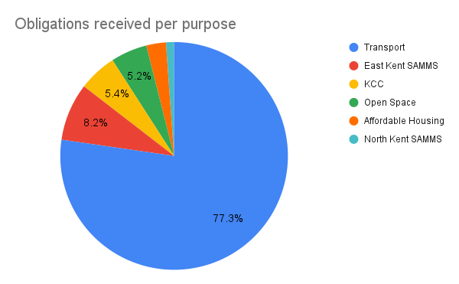

  - The majority of developer contributions for Kent County Council are collected directly by Kent County Council but some are collected by Canterbury City Council and transferred to Kent County Council when required. You can see which council is due to collect the funds by reviewing the relevant legal agreement.
  - The total for KCC in 5.19 and 5.20 consists of contributions that Canterbury City Council received on behalf of Kent County Council. These are: £73,675.20 for Primary Education, £37,131.96 for Secondary Education and £1,203.37 for Libraries.
  - Contributions received directly by Kent County Council will feature in Kent County Council's Infrastructure Funding Statement.
  - Total receipts in financial year 2020/2021 (£2,060,344.07) came from 52 sites, however 95% of these funds came from seven sites:

Application | Amount | Purpose
CA//15/01479 Land off Cockering Road, Thanington | £1,450,444.71 | Transport initiatives including extension of the existing Wincheap Park and Ride.
CA//17/00648  57-61 Military Road, Canterbury | £161,463.34 | Transport and open space, including enhancements to Tourtel Road bus lane and pedestrian link.
CA//19/00451  Land adjacent to Aspinall Close, Bekesbourne | £144,593.80 | Primary and Secondary Education, Libraries, open space and transport
CA//16/00378  Land at Herne Bay Golf Course | £73,579.53 | East Kent SAMMS
CA//17/00809  Arter Brothers, Barham | £57,500.00 | Affordable housing
CA//15/01296 Land north of Thanet Way, Whitstable | £46,833.59 | East Kent and North Kent SAMMS
CA//19/10220  Goose Farm, Sturry | £31,501.76 | Primary Education, Libraries and East Kent SAMMS

Total s106 agreements for financial contributions allocated but not spent in the reported year
  - This section contains information on developer contributions which have been or will be allocated by Canterbury City Council and external parties.
  - These external parties include Kent County Council, East Kent SAMMS, North Kent SAMMS and the NHS Kent and Medway Clinical Commissioning Group.
  - Contributions for these external organisations are counted as allocated, as per the definition of ‘allocated’ on page 4.

Allocated obligations per purpose

Purpose | Amount
Sustainable Transport | £2,245,248.88
Affordable Housing | £1,388,796.41
East Kent SAMMS | £762,036.35
Open space | £639,298.97
KCC | £154,299.63
Business Support | £138,355.16
Health | £15,000.00
North Kent SAMMS | £977.03
Total allocated | £5,344,012.43

  - The pie chart below depicts the data in table 5.29:
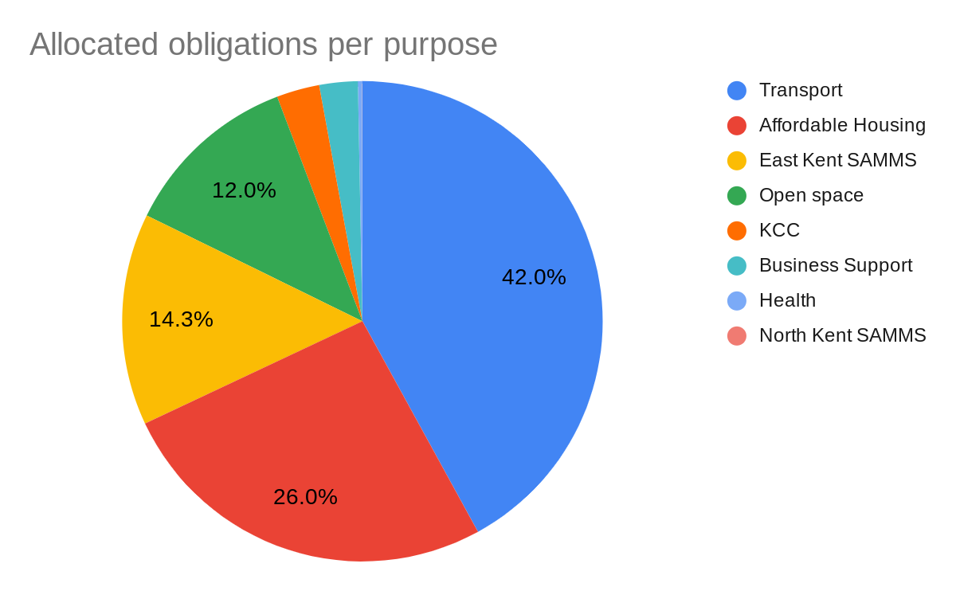

  - The IFS requires councils to provide a summary of details of items of infrastructure to which the funds have been allocated. Please see the appendix for this summary. One planning application can fund several items of infrastructure so the summary includes a line for each of these specific allocations.
  - The IFS also requires councils to provide information on money which was received before the reported year which is due to be allocated. All funds received prior to the reported year are either allocated or spent.

Developer contributions held at the end of financial year 2019/20
  - The table below shows the total s106 developer contributions that Canterbury City Council retained by 31 March 2021:

- Information | Total
Total allocated by end of the financial year (see 5.28) | £5,344,012.43
Total received before FY20/21 which is due to be allocated (see 5.31) | £0.00
Total received in FY20/21 which is due to be allocated | £57,500.00
Total retained | £5,401,512.43

Developer contributions spent in financial year 2019/2020
  - This section of the s106 Report includes all developer contributions that have left the council because they have either been spent by teams within the council (eg the Environment team) or they have been transferred to external parties (eg KCC) to spend.

Total contributions spent, per purpose

Purpose | Amount
KCC | £168,129.81
Sustainable Transport | £138,460.94
North Kent SAMMS | £28,421.91
Business Support | £12,927.99
Open Space | £9,716.99
Total spent | £358,657.64
  - The pie chart below depicts the data in table 5.35:
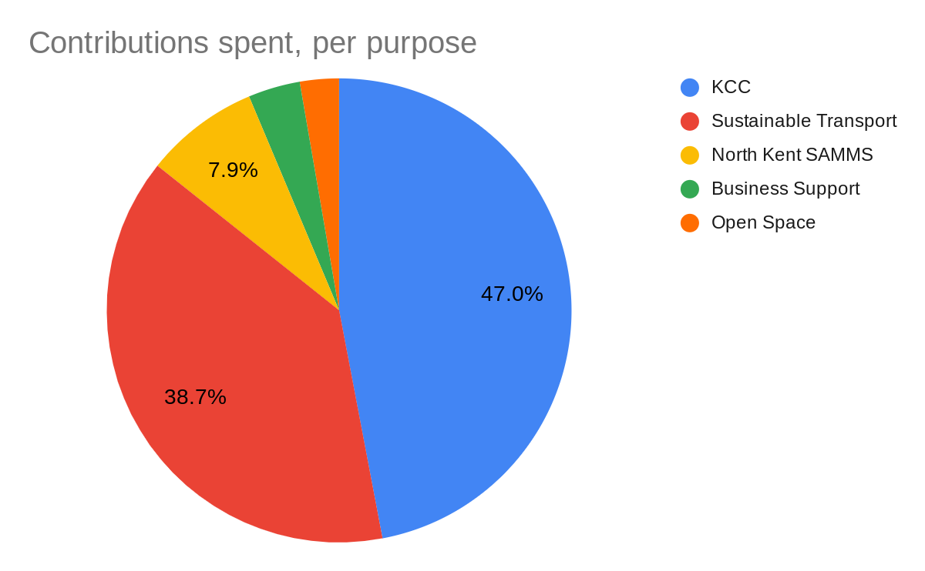

  - Please refer to KCC’s Infrastructure Funding Statement for the reported year for further information on the s106 developer contributions which KCC received from Canterbury City Council and details of how these contributions have been allocated or spent.
  - For information on the ways in which SAMMS payments contribute to mitigating potential disturbance to bird populations on the coast, please visit Birdwise website.

  - Canterbury City Council is required to report on the items of infrastructure on which money received under planning obligations was spent, and the amount spent on each item. These details are listed in the table below:

Infrastructure type | App. no. | Amount spent | Item of infrastructure
Sustainable Transport | CA//15/00450 | £75,000.00 | Repaving scheme in lower St Margaret's Street.
 | CA//16/00375 | £38,099.63 | Resurfacing works along the northern frontage of the development site.
 | CA//15/00602 | £13,029.75 | Completion of tiling and vinyl wrapping at Wincheap subway.
 | CA/09/00778 | £6,884.00 | CCTV installation at Watling Street car park, Canterbury.
 | CA//12/02097 | £3,747.56 | Completion of paving works and fees (Altira, Herne Bay).
 | CA/09/00778 | £1,700.00 | Car club bay markings.
Open Space | CA//15/02786 | £8,226.53 | Fees in connection with Changing Places toilet project and foreshore information boards at Reculver.
 | CA//14/01422 | £1,490.46 | Signage in Kingsmead Field.
Business Support | CA//12/02097 | £12,927.99 | Support of businesses operating within Herne Bay.

Examples of recent s106 developer contribution spend

Repaving scheme in lower St Margaret's Street

  - St Margarets Street is a linear street in Canterbury that links the High Street with Watling Street. The section between Hawks Lane and the High Street was pedestrianised in the 1980s and repaved using red block paving.
  - The section between Hawks Lane and Watling Street remained unpedestrianised with the tarmac carriageway and concrete footways separated by a 60-100mm kerb height.
  - From March to June 2021, a project ran to:

- extend the pedestrianised zone to include the entire length of the street
- remove the kerb height to create a flush surface from one side of the street to the other
- repave the street in high quality natural paving materials

  - Sawn granite setts and sawn, textured yorkstone were selected as paving materials to remain in keeping with the historic environment.
  - The removal of the kerbline enabled much better use of the street for pedestrians and cyclists.
  - It also allows businesses to have more space for tables and chairs to help create a much more vibrant and attractive street.
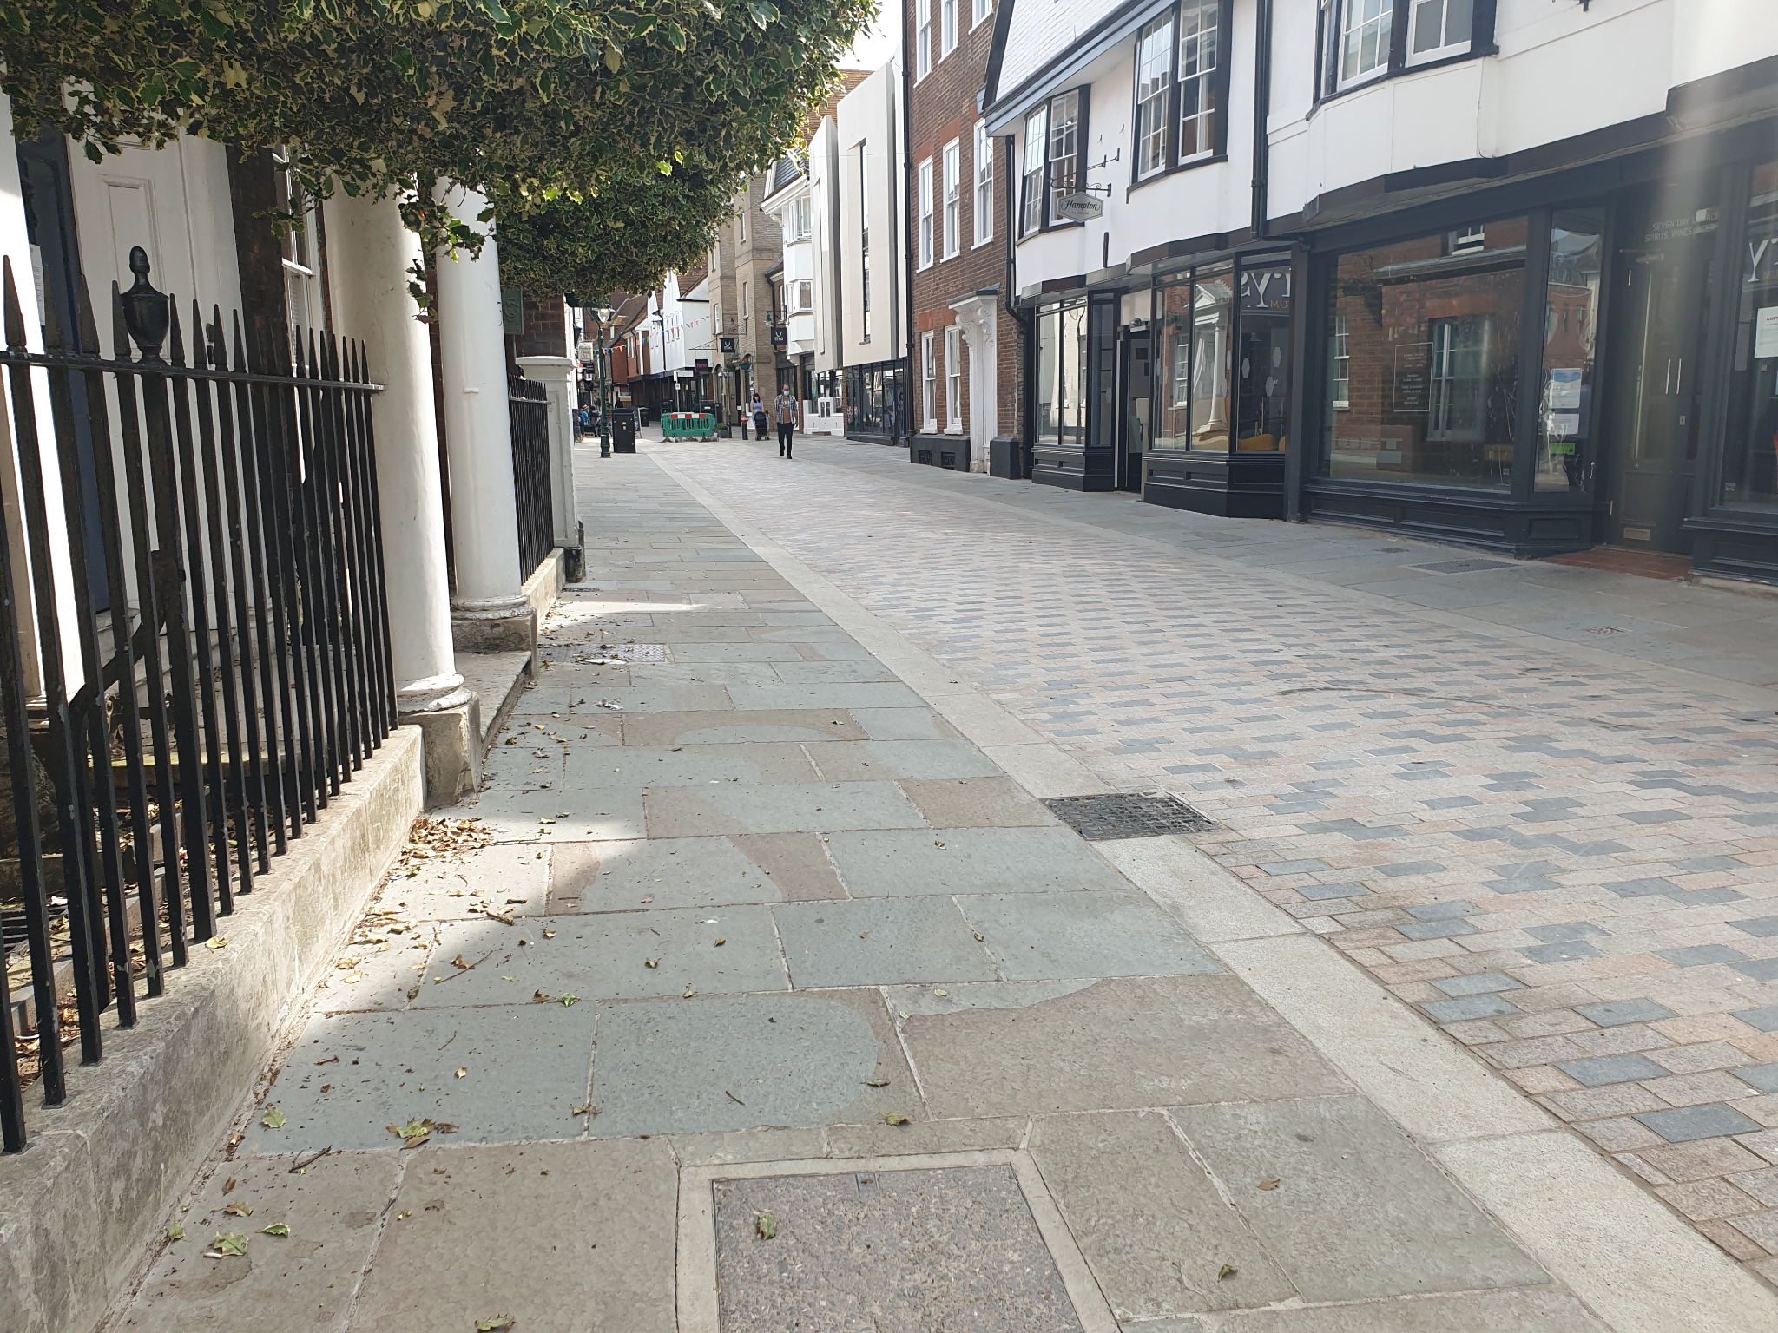

Image of repaving works in lower St Margaret’s Street

Crab and Winkle Cycle route extension

  - The Infrastructure Funding Statement for financial year 2019/2020 details spend towards Crab and Winkle cycle route improvements.
  - These works continued into financial year 2020/2021 (this statement’s reported year), with the scheme substantially completed by December 2020.
  - The objective of the project was to construct an extension of the Crab and Winkle Way to Old Bridge Road.
  - The scheme included the provision of new shrubs and trees along the route of the new path to improve biodiversity and to ensure screening from adjacent properties.
  - The finished path is used by a high volume of pedestrians and cyclists. It provides a direct cycle route to the south side of the railway station and therefore links south Whitstable to the railway station.
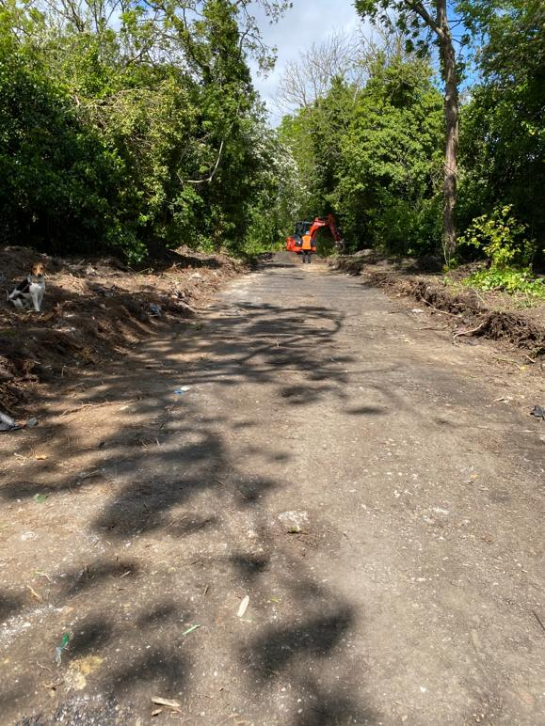

Image of the extension under construction

Images of the finished extension
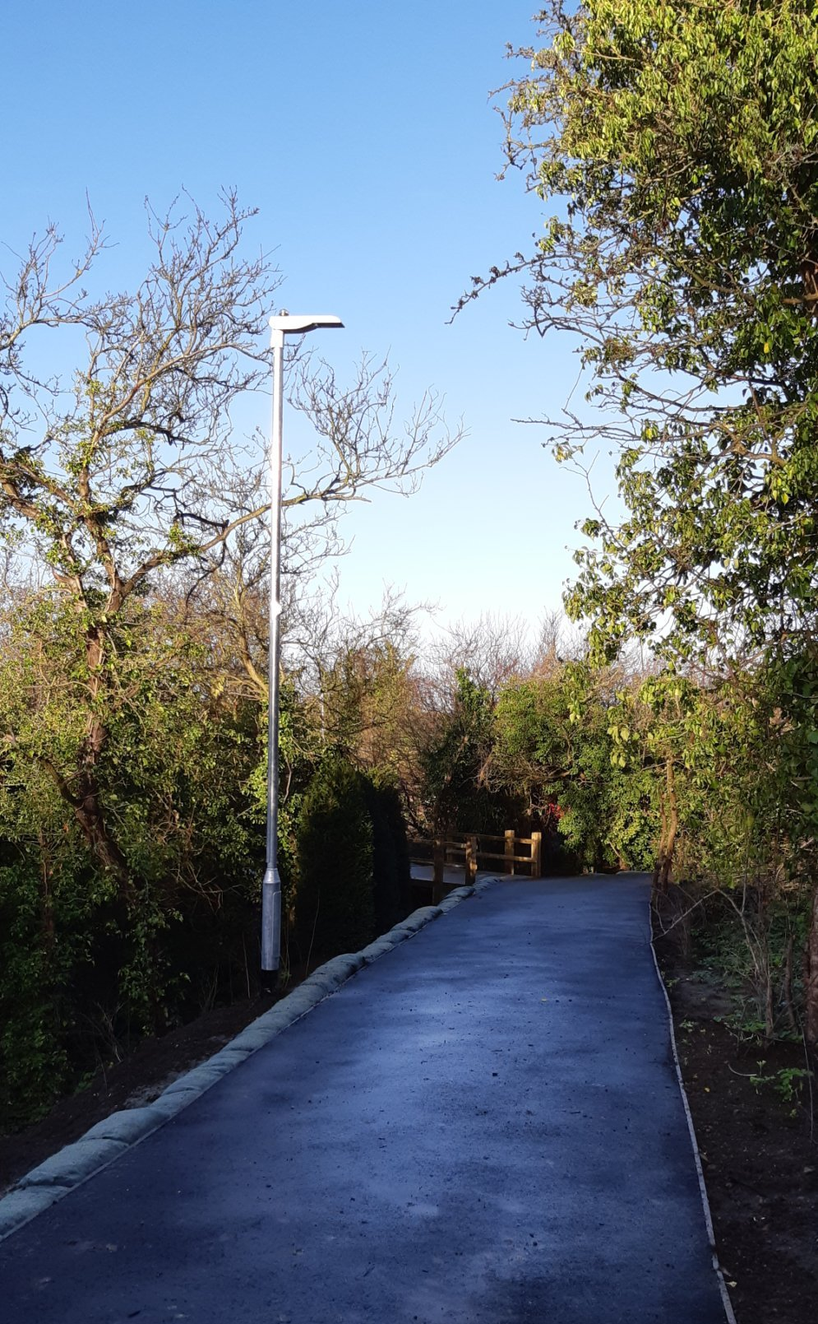
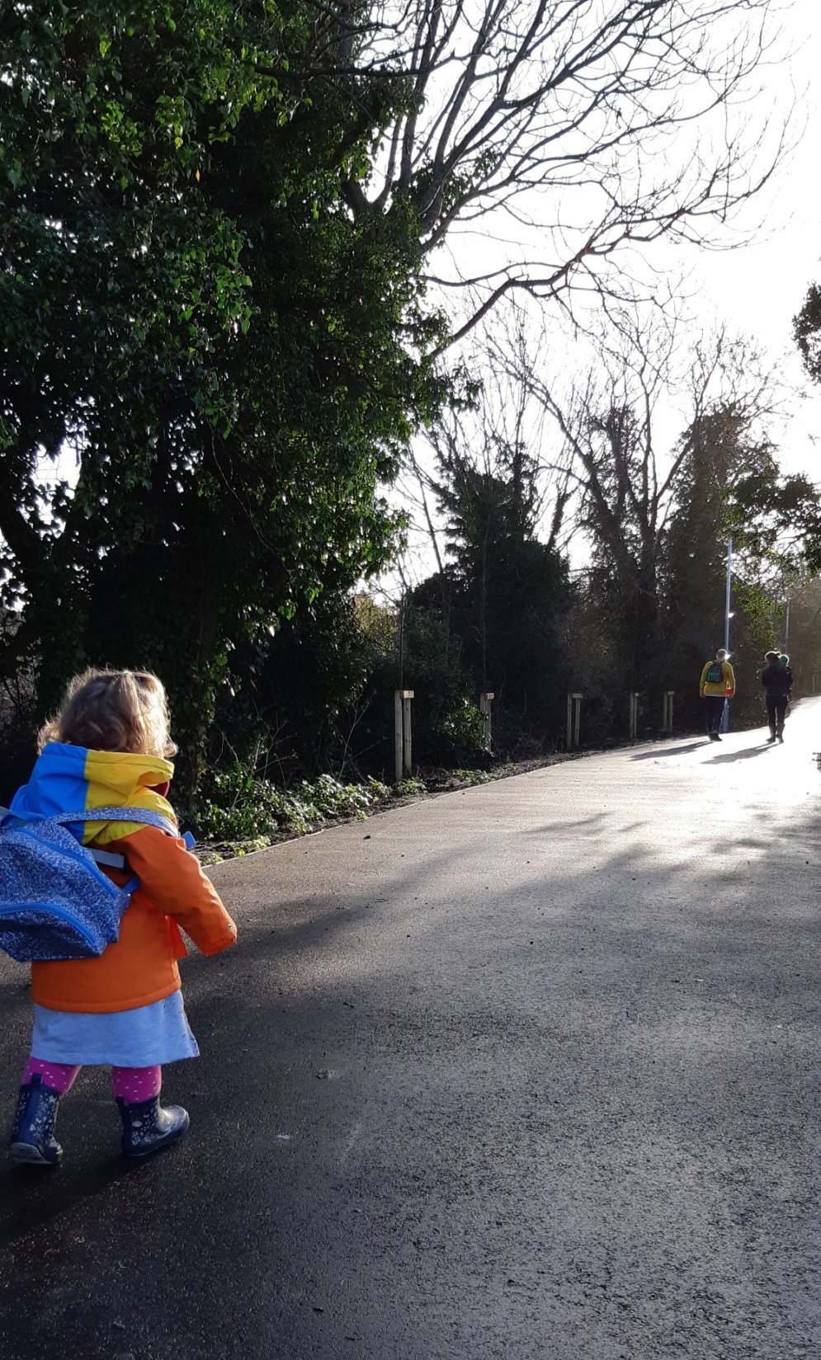

Amount of money spent in respect of monitoring s106 contributions

  - Canterbury City Council is required to report the amount of money received under planning obligations spent in respect of monitoring in relation to the delivery of planning obligations.
  - Monitoring refers to tracking progress of developments to understand if they have reached a 'trigger' for payment as set out in their legal agreement eg to pay a certain sum prior to commencement or prior to first occupation.
  - Monitoring activities mostly involve communication between council officers and developers but can also involve site visits as well as accessing council tax and building control data.
  - Canterbury City Council recently started charging s106 monitoring fees to cover the administrative costs of monitoring and reporting on s106 agreements. No monitoring fee receipts were received in the reported year. Read more about s106 monitoring fees on our website.

Future spending priorities

  - Canterbury City Council's Infrastructure Delivery Plan (IDP) (2019) sets out the future spending priorities on infrastructure and provides information on the infrastructure schemes necessary to deliver the Canterbury District Local Plan (2017).
  - The IDP includes information relating to timing, phasing, delivery, costs and funding of these key infrastructure requirements. Moreover, it outlines how developer contributions such as s106 agreements and the Community Infrastructure Levy (CIL) will be used to deliver planned infrastructure provision.
  - As mentioned in the introduction of this statement, it is anticipated that infrastructure provision will be increasingly funded by CIL, with the exception of strategic development sites and infrastructure required for site-specific mitigation which will continue to be subject to s106 planning obligations.
  - Alongside the IDP, the Council's Infrastructure List (2020) specifies the types of infrastructure that may be funded wholly or partly through CIL and that which will be funded through s106 planning obligations.
  - The publication of the Infrastructure List is intended to provide transparency on how an authority intends to use CIL funds.
  - Both the Infrastructure List and the Infrastructure Delivery Plan will be subject to periodic review and are currently being reviewed as part of the work to develop a new Local Plan to 2040. Read more about the new Local Plan on our website.

Appendices

CIL Report from Hoath Parish Council

Total S106 Developer Contributions Allocated

